NAME:CH HARSHITHA CHOWDARY

REG NO : 192211021

COURSE CODE : CSA1592

COURSE :CLOUD COMPUTING AND BIG DATA ANALYTICS FOR WEB SERVICES

S.NO: 08

SLOT:B



1. Create a simple cloud software application and provide it as a service using any Cloud Service Provider to demonstrate Software as a Service (SaaS).

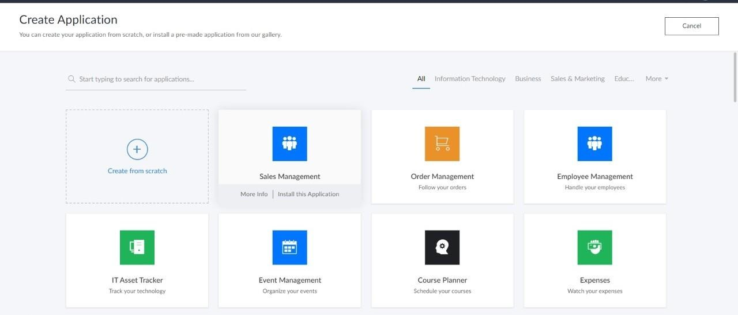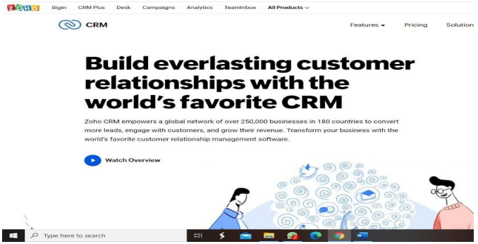

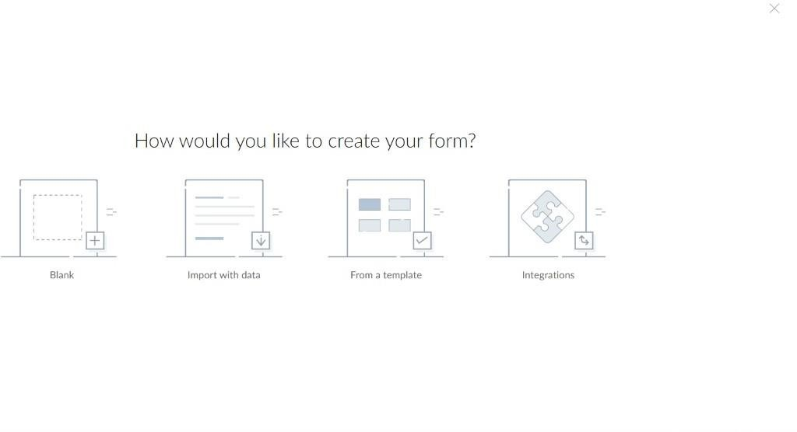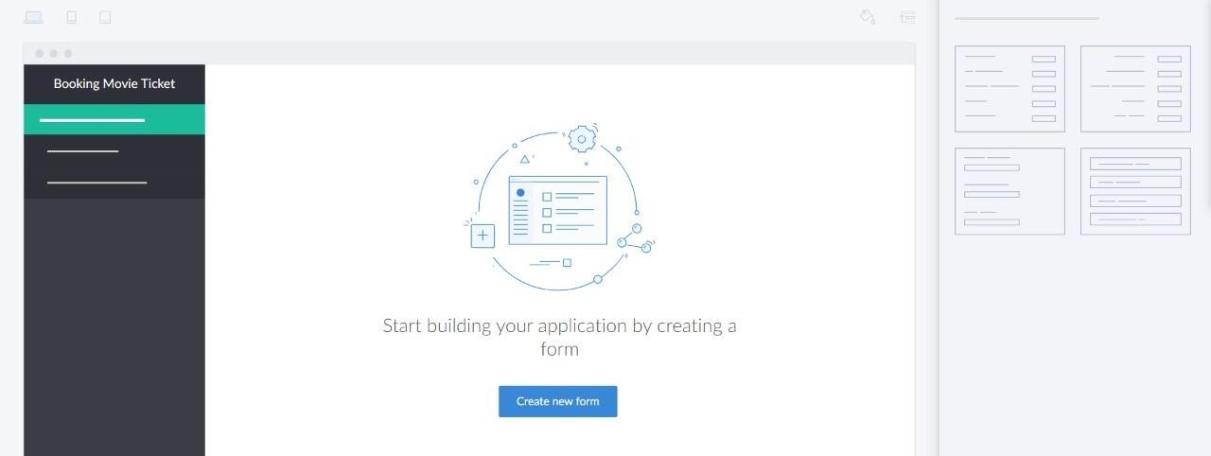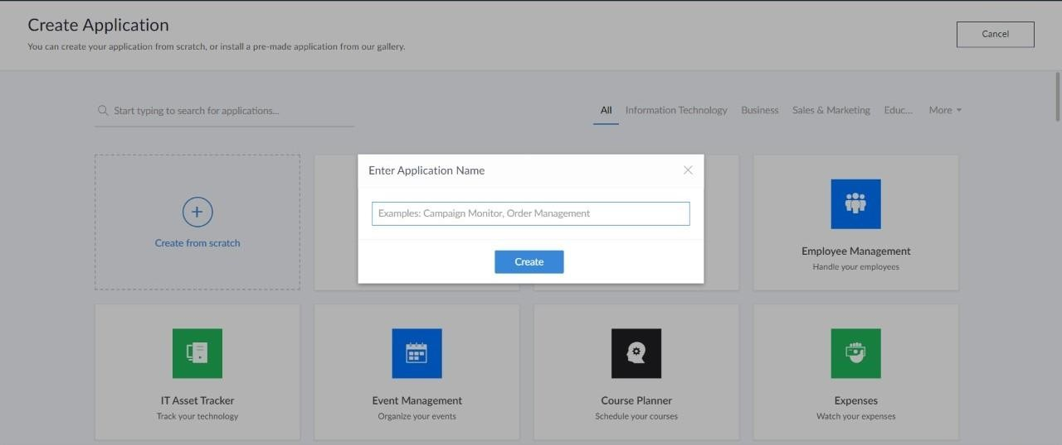

# 

# 2: CREATE A SIMPLE CLOUD SOFTWARE APPLICATION FOR FLIGHT RESERVATION SYSTEM USING ANY CLOUD SERVICE PROVIDER TO DEMONSTRATE SAAS.

# 



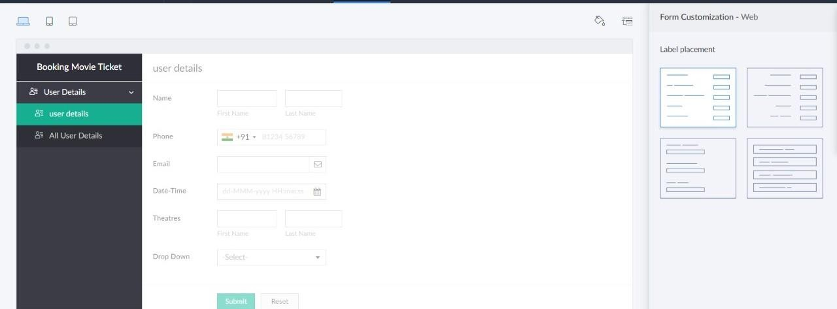

# 3.CREATE A SIMPLE CLOUD SOFTWARE APPLICATION FOR PROPERTY BUYING & RENTAL PROCESS (IN CHENNAI CITY) USING ANY CLOUD SERVICE PROVIDER TO DEMONSTRATE SAAS.

# 

# 

# 

# 4.CREATE A SIMPLE CLOUD SOFTWARE APPLICATION FOR CAR BOOKING RESERVATION SYSTEM USING ANY CLOUD SERVICE PROVIDER TO DEMONSTRATE SAAS.



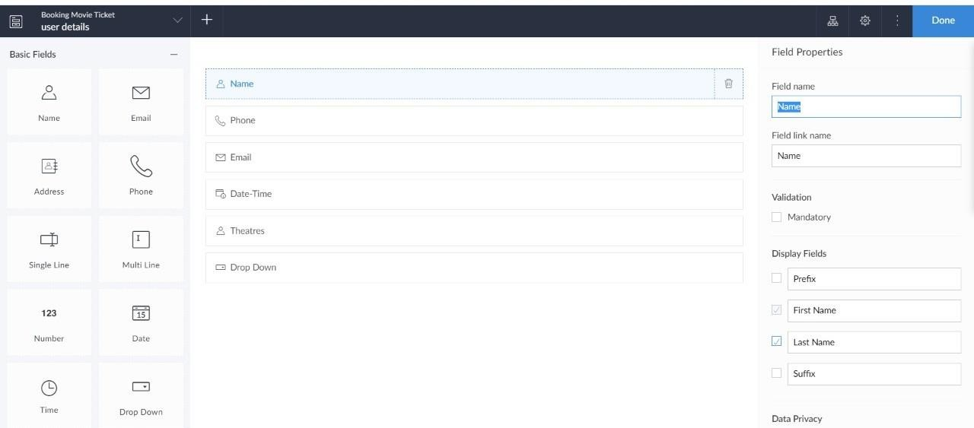

# 5. CREATE A SIMPLE CLOUD SOFTWARE APPLICATION FOR LIBRARY BOOK RESERVATION SYSTEM FOR SIMATS LIBRARY USING ANY CLOUD SERVICE PROVIDER TO DEMONSTRATE SAAS



# 7. DEMONSTRATE VIRTUALIZATION BY INSTALLING TYPE2

**HYPERVISOR IN YOUR DEVICE, CREATE AND CONFIGURE VM IMAGE WITH A HOST OPERATING SYSTEM (EITHER WINDOWS/LINUX**

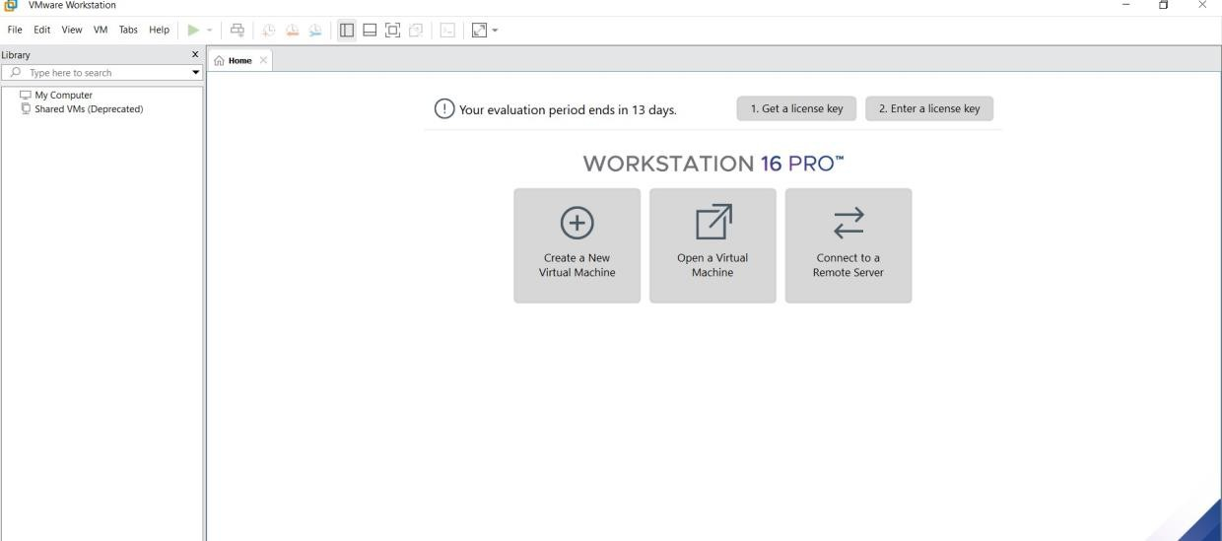

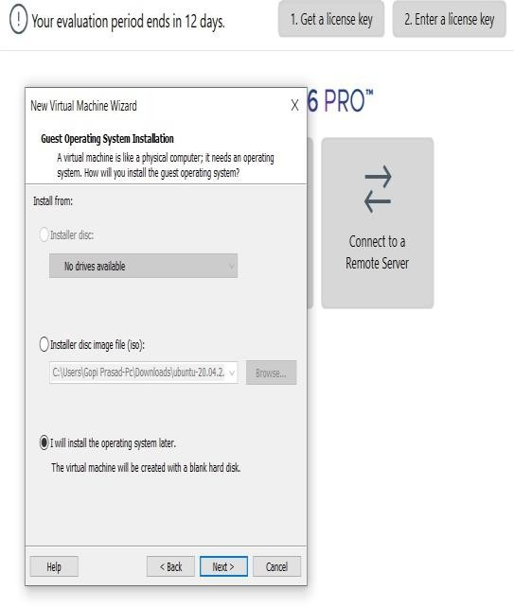

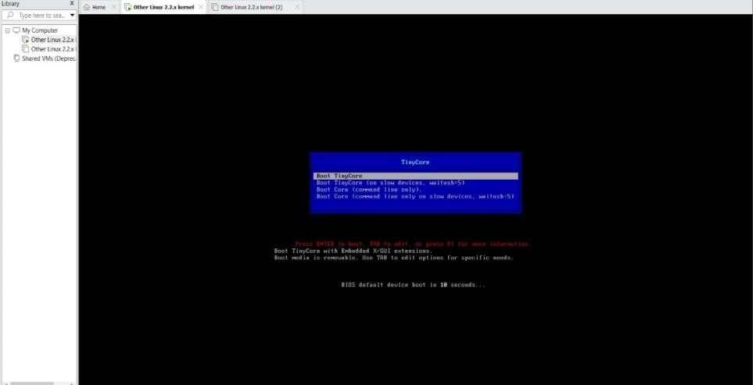

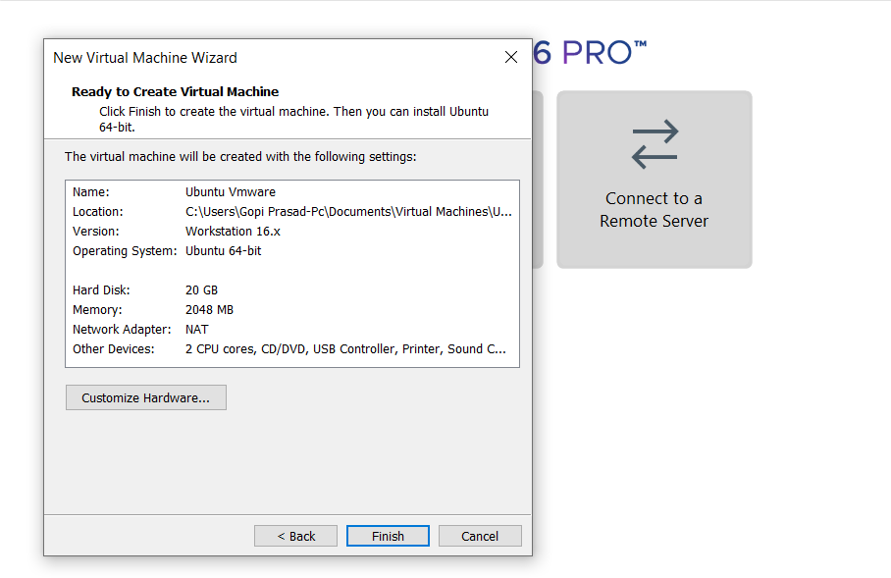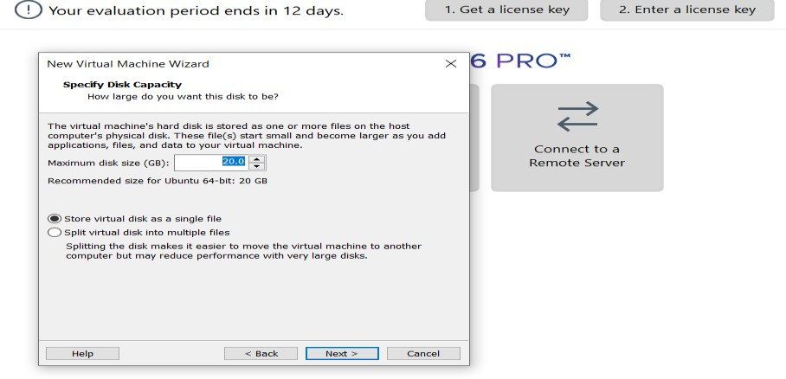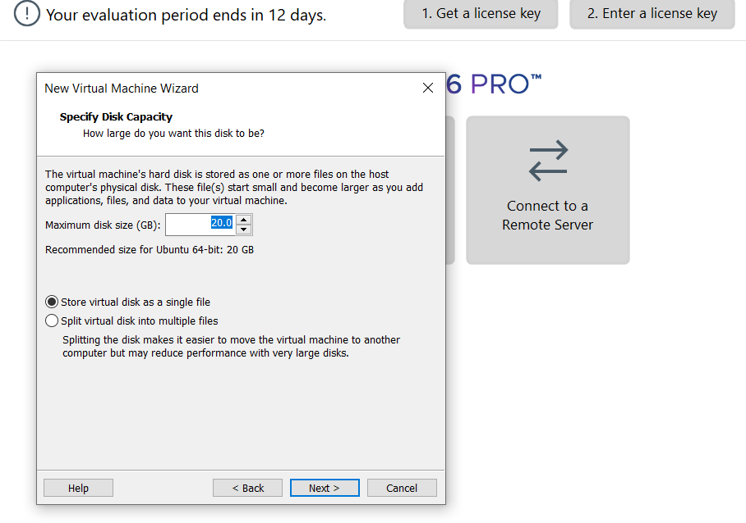

**8: CREATE A VIRTUAL MACHINE WITH 1 CPU, 2GB RAM AND 15GB STORAGE DISK USING A TYPE 2 VIRTUALIZATION SOFTWARE.**

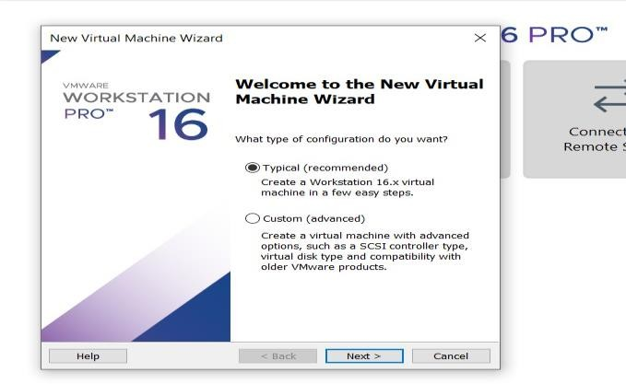



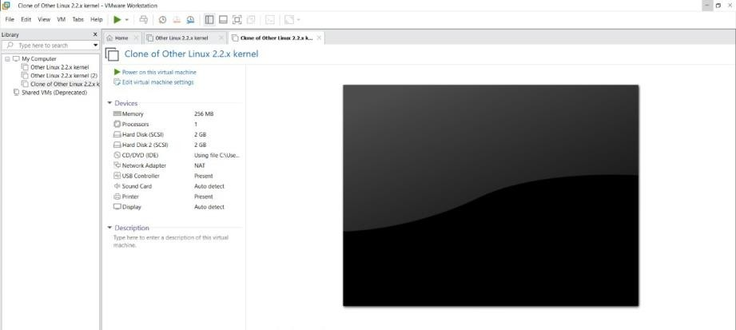

**9: CREATE A VIRTUAL HARD DISK AND ALLOCATE THE STORAGEUSING VM WARE WORKSTATION.**

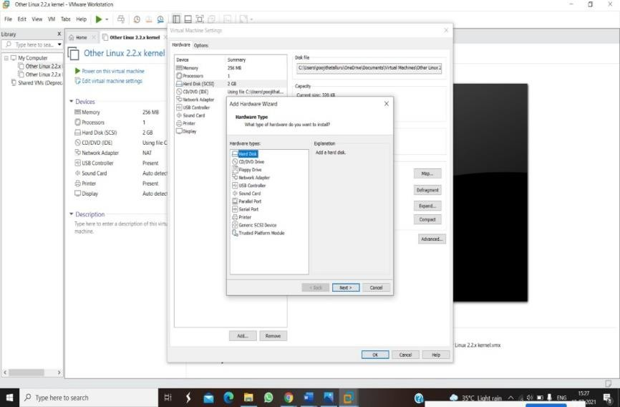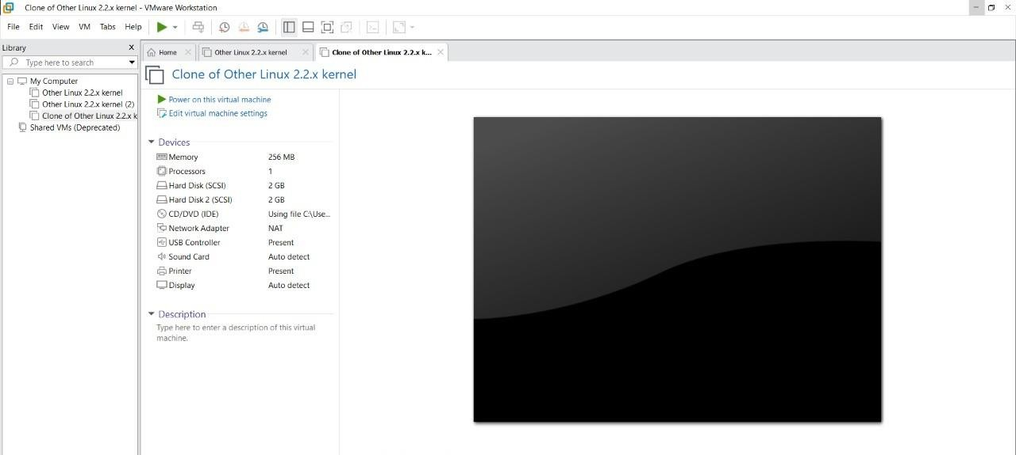

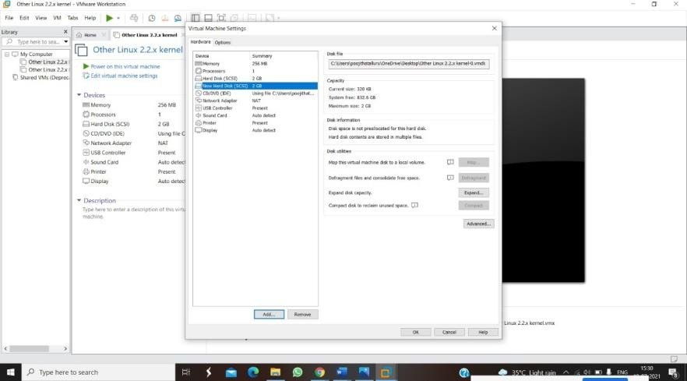

**10: CREATE A SNAPSHOT OF A VM AND TEST IT BY LOADING THE PREVIOUS VERSION/CLONED VM**

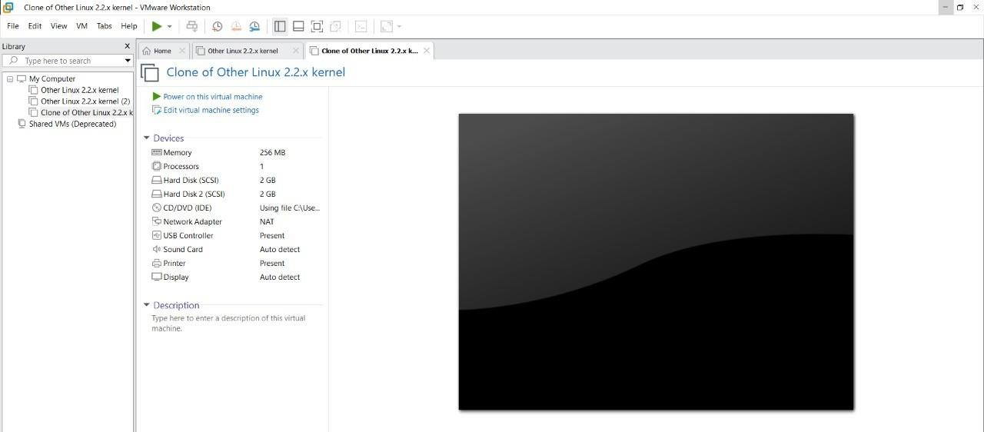

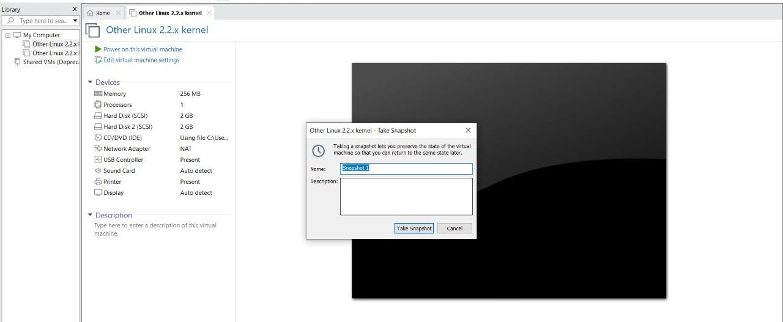

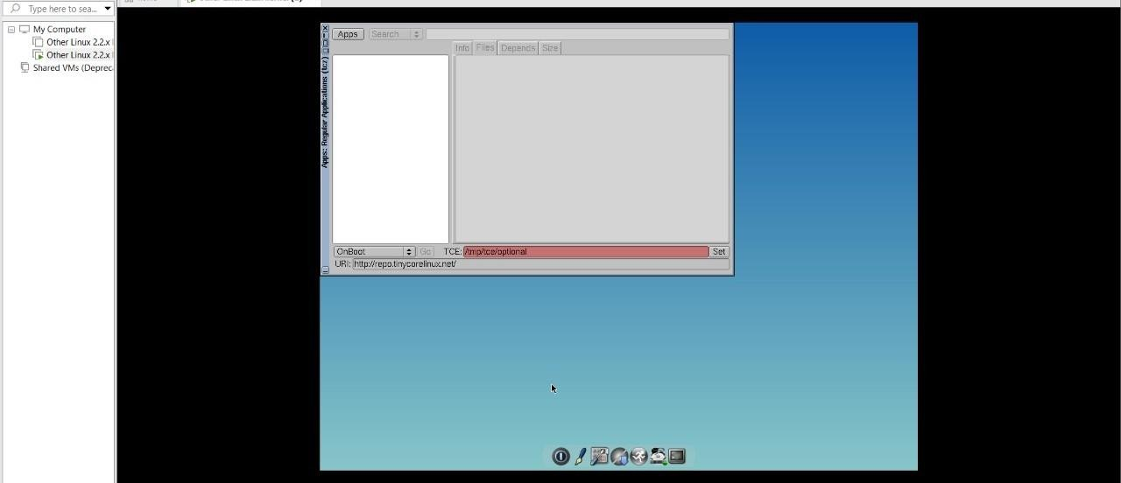

# 11: CREATE A CLONING OF A VM AND TEST IT BY LOADING THE PREVIOUS VERSION/CLONED VM.

# 

# 

# 12: CHANGE HARDWARE COMPATIBILITY OF A VM (EITHER BY CLONE/CREATE NEW ONE) WHICH IS ALREADY CREATED AND CONFIGURED.



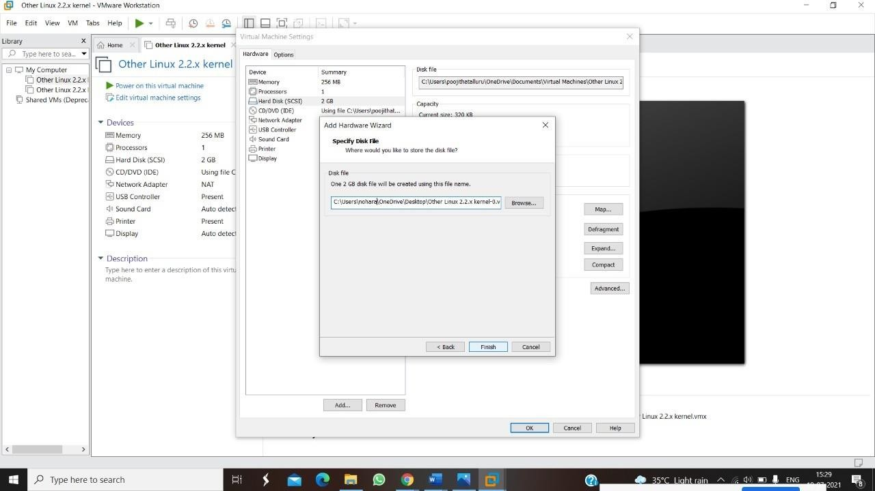



**13.DEMONSTRATE INFRASTRUCTURE AS A SERVICE (IAAS) BY CREATING A VIRTUAL MACHINE USING A PUBLIC CLOUD SERVICE PROVIDER (AZURE), CONFIGURE WITH REQUIRED MEMORY AND CPU.**

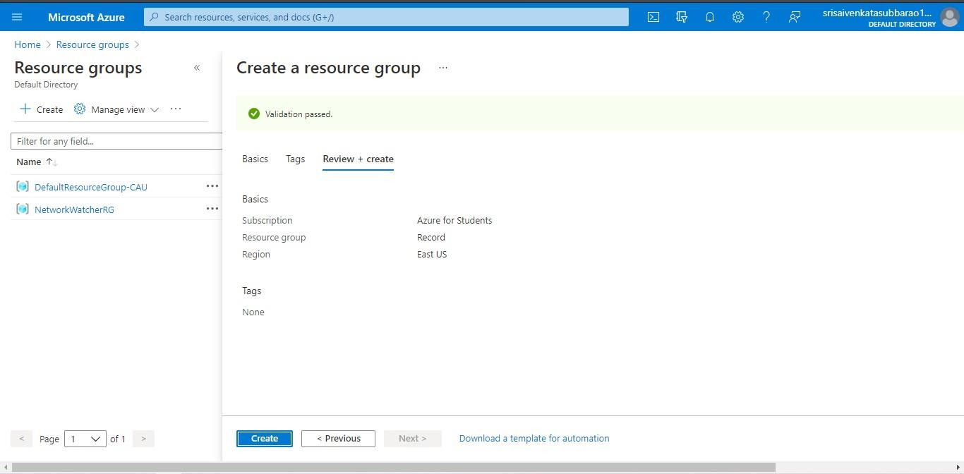

**14.DEMONSTRATE INFRASTRUCTURE AS A SERVICE(IAAS) BY CREATING AVIRTUAL MACHINE USING A PUBLIC CLOUD SERVICE PROVIDER(AZURE/GCP/AWS) CONFIGURE WITH MINIMUM CPU, RAM ANDSTORAGE AND LAUNCH THE VM IMAGE.**



**15.CREATE A SIMPLE WEB SITE USING ANY PUBLIC CLOUD SERVICE PROVIDER (AZURE/GCP/AWS) AND CHECK THE PUBLIC ACCESSIBILITY OFTHE STORED FILE TO DEMONSTRATE STORAGE AS A SERVICE**

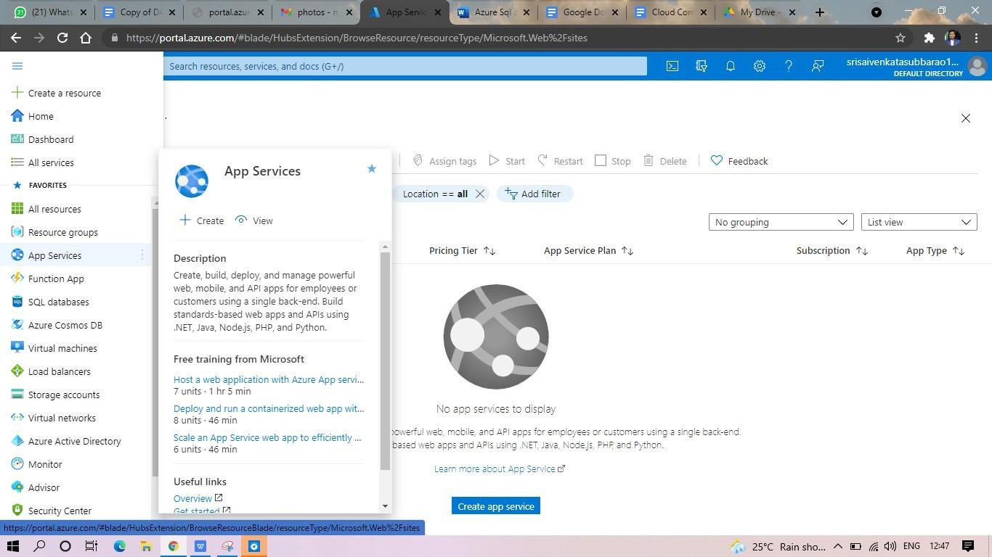

**17.DEMONSTRATE INFRASTRUCTURE AS A SERVICE(IAAS) BY CREATING AVIRTUAL MACHINE USING A PUBLIC CLOUD SERVICE PROVIDER(AZURE/GCP/AWS) CONFIGURE WITH MINIMUM CPU, RAM ANDSTORAGE AND LAUNCH THE VM IMAGE**

**.**

**19.CREATE A STORAGE SERVICE USING ANY PUBLIC CLOUD SERVICE PROVIDER (AZURE/GCP/AWS) AND CHECK THE PUBLIC ACCESSIBILITY OFTHE STORED FILE TO DEMONSTRATE STORAGE AS A SERVICE.**

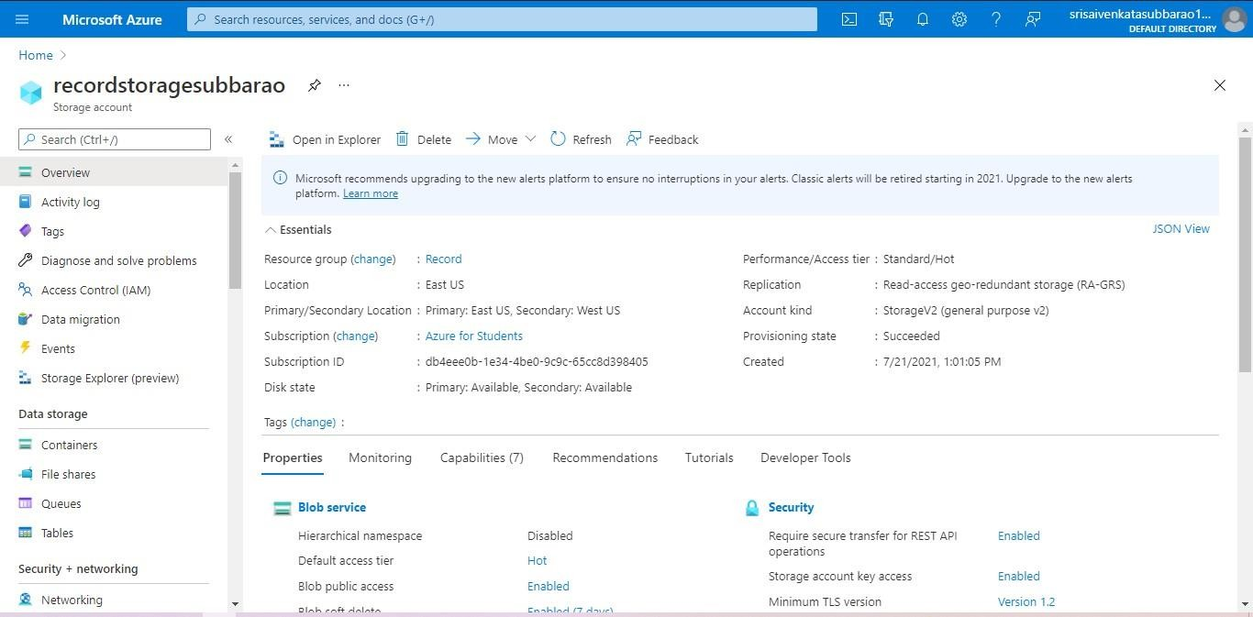

**20.CREATE A SQL STORAGE SERVICE AND PERFORM A BASIC QUERY USINGANY PUBLIC CLOUD SERVICE PROVIDER (AZURE/GCP/AWS) TO DEMONSTRATE DATABASE AS A SERVICE (DAAS)**

